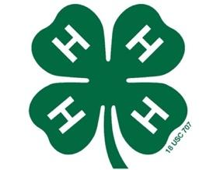
Halifax Harvest Days
4-H Poultry Project Rules

- Youth ages 5-18 as of January 1, 2022, may participate in the program. They must be a current 4-H member enrolled in 4-H online.

- All participants are required to participate in the two educational workshops on September 8th and September 29th at 6:30pm in the Extension kitchen.

- Youth will receive 3 chicks on September 8th to be raised to exhibit at the Halifax County Harvest Days Poultry Show on October 22nd.

- A project record book or poster presentation is required to participate in the show on October 22nd.

- THIS IS A TERMINAL PROJECT! All birds must be brought to the show on October 22nd even if you are not exhibiting them. Broilers are meat birds and are bred to live a short period of time. Allowing these birds to return home with participants is an animal welfare issue.

- Project broilers will be processed on October 26th at the 4-H Rural Life Center. Your family may participate in the processing and take your birds home should you chose to do so.

Entry forms are due by noon on August 31, 2022

